|  |  |  |
| --- | --- | --- |
|  | **ELP 725** |  |
|  | **Wireless Communication Lab** |  |
|  |  |  |
|  |  |  |
|  | **Project Synopsis** |  |
|  | **Intelligent Vehicle Monitoring System**  **using Wireless Communication** |  |
|  |  |  |
|  | **iitd** |  |
|  |  |  |
|  | **Indian Institute of Technology, Delhi** |  |
|  |  |  |
|  |  |  |
|  |  |  |
|  | **Submitted By :** |  |
|  | **Anshuman Singh (2018JTM2004)**  **Pardhi Chandan Waman(2018JTM2248)** |  |
|  | **Group Number 8** |  |
|  | **02th March 2019** |  |

**Intelligent Vehicle Monitoring System**

**using Wireless Communication**

**Abstract**

The use of mobile phones while driving is one of the most dangerous and widely seen causes of fatal road accidents. The objective of the paper is to develop a device to find people who use mobile phones while driving and evade from stringent laws enforced by the government easily. This novel and ingenious technique facilitates the government to take adequate action against those who are violating these laws. To meet the requirements of an intelligent vehicle monitoring system,this architecture integrates Global Position System (GPS), Global System for Mobile communications (GSM) and a Micro controller in the whole. This device is used to prevent texting and calling of mobile phones while driving vehicles.If the driver is using the phone while the vehicle is in motion, it triggers a signal which notifies the cops with the vehicle’s number plate and the location with the help of GPS system.It receives the mobile signal and detects the presence of mobile. This signal eventually triggers the micro-controller with a glowing LED. Due to the voltage fluctuation, the message is sent to the cops using GSM communication.

**Block Diagram**

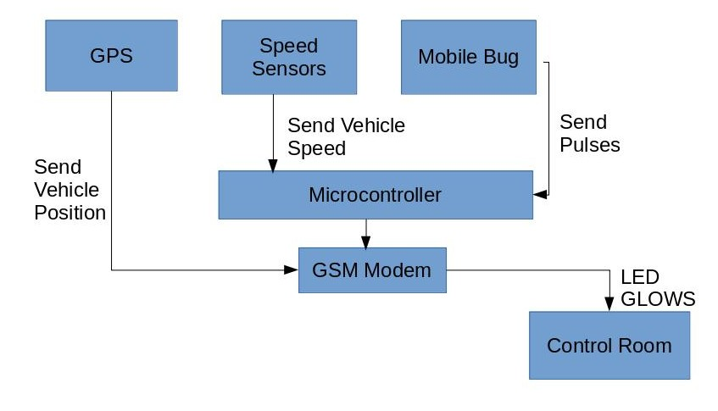

**Hardware Specifications**

1. Arduino Uno
2. GSM Module (SIM800A)
3. GPS Module (Ublox NEO-6M)
4. IC CA3130
5. IC NE555
6. Speed Measuring Sensor Groove Coupler Module For Arduino
7. Power supply
8. Buzzer
9. LED’s
10. Switches
11. Push Buttons
12. Capacitors
13. Resistors

**Application**

This project could help to save precious human lives by reporting the use of mobile phones while driving. Frequent offenders could be punished by authorities to culminate better driving habits among public.

In future, a small jammers constrained only to drivers cabin may be designed and if the vehicle is moving at a speed more than 40km/hr then the jammer should be activated and the driver should be barred from receiving as well as making calls and messages.